(Approx. 492 words)

Knoppix Live CD
By Cal Esneault, President, Cajun Clickers Computer Club, LA and leader of many Open Source Workshops & SIGs
April 2012 issue, Cajun Clickers Computer News
http://cccclinuxsig.pbwiki.com
www.clickers.org
ccnewsletter (at) cox.net

About seven years ago I was introduced to Xandros GNU/Linux by the Cajun Clickers. Like most distro’s then, it required a full installation onto the hard drive, a step for which I was not ready. Knoppix, a GNU/Linux system developed by Klaus Knopper of Germany, was then a rare version in that it could run from a CD without modifying the hard drive (known as a “live” CD). Knoppix allowed me to explore and appreciate Linux without having to jeopardize my existing system.

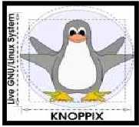

Since then, almost all major distro’s offer downloads with “live” media choices that
allow you to preview the OS and optionally install the OS directly from that media.

The strength of Knoppix is the excellent hardware detection and minimal configuration to get a working system. It shines as a system rescue and maintenance tool for working with other systems. For example, it can mount and access most other Linux or Windows
partitions automatically. While it can be permanently installed, it is typically used with “live” media (CD, DVD, USB, …). Advanced methods exist to modify or give “permanence” to Knoppix, and many experts remaster their own customized versions.

I downloaded and burned a copy of the latest CD (iso Knoppix 6.7.1). A screenshot of the desktop menu and 3 open applications is shown below.

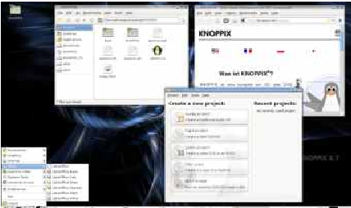

Currently Knoppix uses a lightweight 32-bit LXDE desktop (see my November 2011 article on LXDE). PCManFM is the file manager, and Iceweasel is the Internet browser. With this configuration, Knoppix hardware specs should allow it to run on older systems.
Surprisingly, it includes the powerful (and bulky) GIMP and LibreOffice programs. My biggest surprise was that it included Compiz compositing manager which gives tremendous graphics effects for screen “eye candy.” See below an intermediate screen as an application window dynamically explodes into squares during application exit.

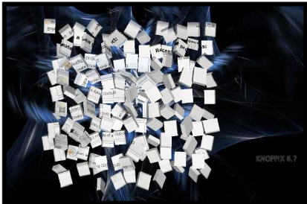
While this is interesting for those with modern graphic cards, my experience was that it made less powerful systems hang-up and require reboot. I solved this by using the cheat-code “knoppix no3d” at the boot prompt to restrict Compiz and give a working desktop.

Knoppix is an example of the unique combination of software that can be assembled when the distro is the work of a single developer. For example, there are tools for system and network administrators, applications for system rescue and repair, and a version for blind users (based on ADRIANE). Since my first encounter, Knoppix has introduced over a dozen versions with use of many new concepts (early to use KDE 4.x, early to use LibreOffice, etc.). This distro is a utilitarian system suited for experienced Linux users who want to learn more about their systems. Learn more by visiting
www.knopper.net/knoppix, or look for Knoppix in the top search boxes at www.distrowatch.com.

